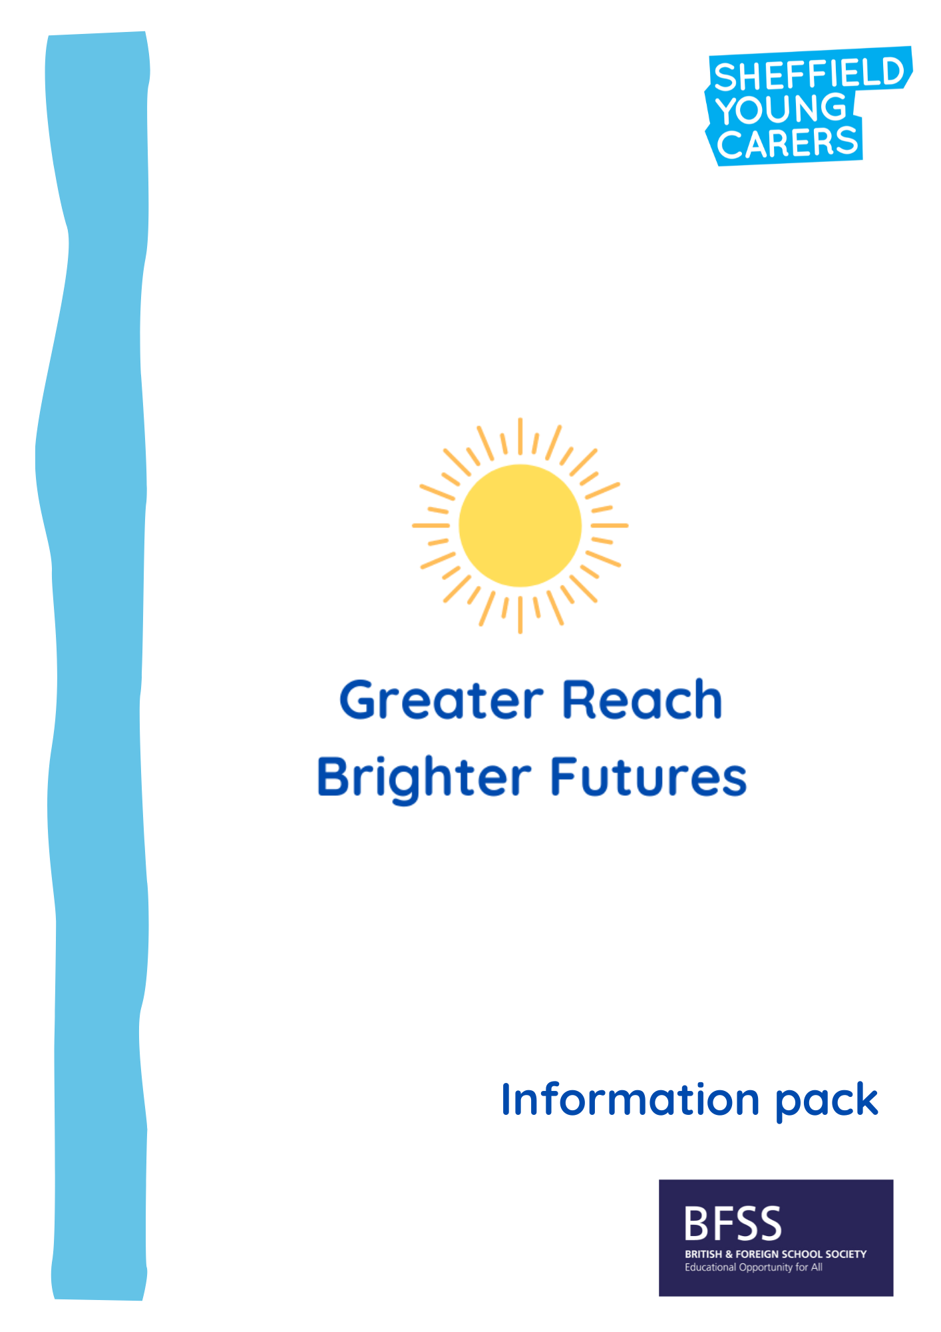

Contents

What is Greater Reach, Brighter Futures? | 3
Who are young carers? | 4
Young carers and education | 5
Greater Reach, Brighter Futures: Our offer | 6
Greater Reach, Brighter Futures: What we ask of you | 7
Expression of interest form | 8
Appendix 1: Sheffield Young Carers background information | 10

What is Greater Reach, Brighter Futures?
Greater Reach, Brighter Futures is a three-year project funded by the British and Foreign School Society and delivered by Sheffield Young Carers (SYC) in partnership with Learn Sheffield and Sheffield City Council. The project will work with up to six education providers in the first year, and a further four in the second year, in order to provide a package of support that will enable settings to identify, support young carers, and improve educational outcomes. There will be no cost for this and the support offered to each setting will be flexible and tailored to their individual needs.
From Spring 2023 there is going to be a new Young Carer indicator on the schools’ census return for all schools (not nurseries). This indicator will record whether the pupil has been identified as a young carer and by whom. Whilst data from a 2010 BBC study suggests 1 in 12 young people may be a young carer (up to three in every class), education settings often struggle to identify this very hidden group. Young carers face a number of barriers in education, including difficulties with attendance and attainment that see them achieving significantly lower attainment at GCSE level than their peers, whilst also being four times more likely to have to drop out of their college or university course than other students (Children's Society, 2013).
Greater Reach, Brighter Futures’ support package will help education providers to identify and support young carers in their setting by providing training and awareness raising, specialist resources, consultation and staff development, as well as the chance to achieve an accreditation recognising best practice. The project will also monitor and evaluate this work in order to measure the impact of improved identification and support on young carers’ attainment and attendance. In our previous VOYCE schools project, over 60% of young carers supported saw an improvement in attainment in English and Maths, and 95% reported positive emotional well-being outcomes.
More detailed information about the package of support offered through Greater Reach, Brighter Futures, as well as details of how to apply, can be found in this pack.
If you have any questions or would like to discuss the project further, please contact Shuna Beckett, our Education Development Worker.
shuna.beckett@sycp.org.uk 07923 254043
Who are young carers?
A young carer is a child or young person who provides substantial unpaid care for a relative who has disabilities, long-term physical illnesses, mental health difficulties and/or drug or alcohol issues. They may have practical and/or emotional caring responsibilities that an adult would normally take on.
Young carers provide help by doing things like:
- jobs around the house
- shopping
- helping with personal care (bathing, getting dressed)
- giving medication
- providing emotional support
- helping with finances
- looking after themselves or their brothers and sisters.
Young carers can often find life tiring, worrying and lonely. Being a carer can affect a young person in many ways – including social isolation, bullying, difficulties with school attendance and achievement, and physical and mental ill health themselves.

Covid-19 has also disproportionally disadvantaged young carers and there are also likely to be many new young carers as a result of the Coronavirus pandemic.

Young carers and education
Young carers face a number of barriers when it comes to education, and their caring role can often impact on their attendance and attainment:
- Young carers have significantly lower educational attainment at GCSE level - the equivalent to nine grades lower overall than their peers (Children’s Society, 2013)
- A quarter of young carers were bullied at school because of their caring role (Carers Trust, 2013)
- Young adult carers appear to be four times more likely to have to drop out of their college or university course than other students (Children’s Society, 2013)
- Young adult carers aged between 16 and 18 years are twice as likely to be not in education, employment, or training (NEET) (Children’s Society, 2013)

When young carers are identified early and supported well in their education setting, however, they can go on to achieve just as well as their peers.
Young carers and safeguarding
Education settings should be aware of the needs of this particularly disadvantaged group who are named specifically in the Keeping Children Safe In Education statutory guidance for schools and colleges (2022):
Any child may benefit from early help, but all school and college staff should be particularly alert to the potential need for early help for a child who […]
- is a young carer​
- is in a family circumstance presenting challenges for the child, such as drug and alcohol misuse, adult mental health issues and domestic abuse​ (p.7).
The designated safeguarding lead (and any deputies) should undergo training […] so they […] are alert to the specific needs of […] young carers (pg. 166).

Greater Reach, Brighter Futures: Our offer
Greater Reach Brighter Futures aims to build capacity and skills within education settings to identify and support students with caring responsibilities. As a result of this, we expect that young carers will demonstrate improved educational outcomes, including improved attendance and/or attainment.

Greater Reach, Brighter Futures will offer a free, flexible package of support that can be tailored to the individual needs of each education setting. Over one year, each participating setting will be entitled to the following:

Identification and support of young carers
- Access to our education resources including our Young Carers Lead pack and our bespoke identification process
- Support to run the identification process in your setting and to establish support for the young carers you identify
- Ongoing post-project support through membership of our Young Carers School or College Networks (where this is appropriate for your setting)

Training and awareness raising
- A training session for your whole setting on identifying and supporting young carers (done during a twilight or similar)
- 1 x specialist training day on identifying and supporting young carers
- 1 x specialist training day on working directly with young carers
- Access to our one hour e-learning module for all future staff who join your setting.

Strategic support
- Up to 2 days of bespoke and expert support in your setting
- Half-termly reviews and support meetings (online or in person)
Lasting impact
- A final impact report including data and evaluation from the project
- Support to achieve accreditation for your work with young carers.
- Opportunities to celebrate and share learning and best practice locally and nationally.

Greater Reach, Brighter Futures: What we ask of you
In order for the project to work effectively, as well as to deliver the best experience and results for staff and young people, it’s important that education providers are able to commit to certain requirements. The commitments below are informed by our work with education settings over a number of years and form our minimum standard for participation:
- Identify a Young Carers Lead within your setting, and a Young Carers link in the Senior Leadership Team (or equivalent).

- Identify further staff to carry out the project as appropriate.

- Young Carers Lead and Young Carers SLT link to take part in half-termly meetings with Sheffield Young Carers to review progress.
- Engagement of setting staff in the project, including to attend all training sessions and implement identification and support processes.
- Complete monitoring and evaluation processes throughout the project, including collecting and sharing relevant data with Sheffield Young Carers.
- Agree SYC can share good practice and learning with funders, partners and other education settings in the city.

- Willingness of setting staff to pilot our new e-learning training.

- A continued commitment to identifying and supporting young carers and supporting their educational progress beyond the GRBF project.
Project timescales for first cohort:
- 18th November 2022: Deadline for expressions of interest
- By end of December 2022: Applicants informed of outcome
- April – July 2023: Initial meetings with successful applicants to discuss project in more detail and agree Service Level Agreement
- September 2023 – July 2024: Project takes place
GRBF: Expression of interest form
Deadline for applications: 18th November 2022

Education setting name:

Type of setting (please circle or delete):
Primary / Secondary / Special / Alternative Provider / Sixth Form / College / University

Head teacher/setting lead name and email:

Nominated lead contact (Senior Leader or equivalent) name and email:

Number of young carers currently identified in your setting:

Please tell us about your setting’s current approach to identifying and supporting young carers (if any), including any challenges you have experienced:

Continued over...
Please tell us why you would like to be a part of this project, and how you feel your setting would benefit:

If your setting has been involved in the Young Carers Schools Network, please confirm who attends on your behalf.
Name:
Role:

Please sign and date below before sending in your response.
Head teacher/setting lead:
Nominated lead contact/Senior Leader or equivalent:
Date:
Thank you for your interest in Greater Reach, Brighter Futures. Applications will be anonymised and judged by a panel of young people and staff from SYC, and we will let you know if you have been successful by the end of term. If you would like to discuss anything in the meantime please get in touch with Shuna Beckett, shuna.beckett@sycp.org.uk.
Please submit your completed form by 18th November 2022.
Post to: Shuna Beckett, Sheffield Young Carers, Unit R7b Riverside Block,
Sheaf Bank Business Park, 20 Prospect Road, Sheffield, S2 3EN
Scan via email to: shuna.beckett@sycp.org.uk
Alternatively, you can complete our online Expression of Interest form here.

Appendix 1: Sheffield Young Carers – background information
Sheffield Young Carers (SYC) has been in operation since 1997 and the work of the organisation has changed and grown over time. Currently, SYC delivers the following areas of work:

Support for young people
Flexible and responsive support for young carers and young people affected by familial substance misuse aged 8-25 across Sheffield to provide respite and build resilience and confidence. Through SYC Direct, young people are offered one year of support which includes:
- A referral call to introduce ourselves and the service
- Between four and six one-to-one sessions, in school where possible, based on the needs and interests identified by the young person
- A minimum of one term of evening groups. Each term’s programme is planned around the needs identified by the group members that term.
- Access to school holiday activities for one year, including trips and fun events for the whole family
- Training and participation opportunities
- Advocacy and case working
- Signposting and referrals where appropriate (including access to counselling)
- Access to our Action Group young people aged 12-25 who have been members of SYC within the last year and want to be more involved in running SYC

Family Project
Available to families where there is a young person providing care.
- Intensive one-to-one support of up to 12 sessions, with the aim of reducing the caring that the young person is doing and improving life for the whole family.
- Support on a wide range of issues including re-engaging into substance misuse or mental health services, housing issues, budgeting, access to small pots of funding, training around parenting, and help with overcoming conflict in the family.
- Access our parent networking events to meet other adults in similar situations to share experiences and have respite from home.
- Group work sessions for parents to build confidence and develop their skills.
- Support for parents to get into activities and services in their local areas as our provision is ending.

Young Carers Activity Fund
- Up to £300 to give individual or groups of young carers a break from their caring role
- For full details, see: www.sheffieldyoungcarers.org.uk/young-carers-activity-fund

Development and Strategic Work
SYC also work city-wide to ensure good quality support is available to young carers and young people affected by substance misuse in their families, both on a strategic and operational level.

